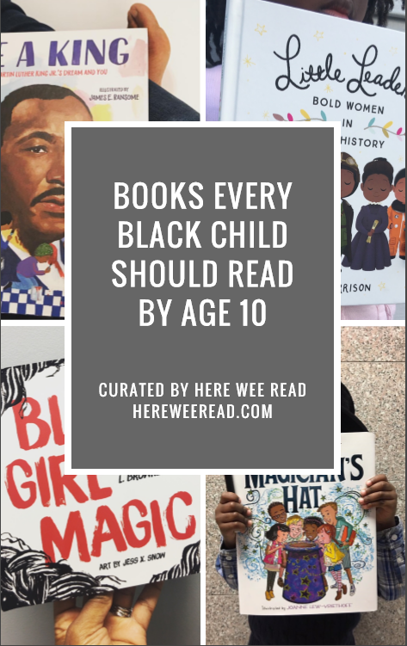
Curated by Here Wee Read
Board Books - Ages Birth to 3
Dream Big, Little Leader by Vashti Harrison (Publishes Oct. 2018)
Shades of Black: A Celebration of Our Children by Sandra L. Pinkney (Also available as a picture book)
Picture Books - Ages 4 to 8
Classics
A Chair for My Mother by Vera B. Williams
Amazing Grace by Mary Hoffman
Corduroy by Don Freeman
Something Beautiful by Sharon Dennis Wyeth
The Snowy Day by Ezra Jack Keats
Newer Picture Books - Ages 4 to 8
Ada Twist, Scientist by Andrea Beaty
Come Sunday by Nikki Grimes (poetry)
Corduroy Take a Bow by Viola Davis
Dancing in the Wings by Debbie Allen
Early Sunday Morning by Denene Millner
Max and the Tag-Along Moon by Floyd Cooper
Black History
A Dance Like Starlight: One Ballerina's Dream by Kristy Dempsey
Barack by Jonah Winter
Michelle Obama First Mom by Carole Boston Weatherford
Grandad Mandela by Ambassador Zindzi Mandela and Mandela, Zazi and Ziwelene
Hidden Figures by Margot Lee Shetterly
Let the Children March by Monica Clark Robinson
Lillian’s Right to Vote by Jonah Winter
Ron’s Big Mission by Rose Blue
Ruth and the Green Book by Calvin Alexander Ramsey
Through My Eyes by Ruby Bridges
Book for Coping with Loss of a Loved One
If You Look Up to the Sky by Angela Dalton
Books for Affirming Pride in Themselves, Their Race & Culture, Teaching Kids They Can Achieve Greatness
Big Hair, Don't Care by Crystal Swain-Bates
Crown: An Ode to the Fresh Cut by Derrick Barnes
Hey, Black Child by Useni Eugene Perkins
I Am Enough by Grace Byers
I Love My Hair! by by Natasha Anastasia Tarpley
I’m a Brilliant Little Black Boy by Betty K. Bynum
I’m a Pretty Little Black Girl by Betty K. Bynum
My Hair is a Garden by Cozbi Cabrera
Our Children Can Soar by Michelle Cook
Black Fairy Tales
Mufaro’s Beautiful Daughters by John Steptoe
Rapunzel by Rachel Isadora
Hansel and Greta by Rachel Isadora
Fatherhood
My Daddy Rules the World by Hope Anita Smith
Daddy Calls Me Man by Angela Johnson
Visiting Day by Jacqueline Woodson
Book to Teach Kids Not to Value Material Things, Have Empathy for Others and Share with Others
Those Shoes by Maribeth Boelts
Early Reader/Middle Grade Chapter Books or Longer Picture Books - Ages 8 - 12
Black History
A Child’s Introduction to African-American History by Jabari Asim
Little Leaders by Vashti Harrison
Other Recommendations
Marley Dias Gets It Done And So Can You by Marley Dias
Black Girl Magic by Mahogany L. Brown (poetry)
The Crossover by Kwame Alexander
Brown Girl Dreaming by Jacqueline Woodson
The Parker Inheritance by Varian Johnson
Ghost Boys by Jewell Parker Rhodes
Schomburg: The Man Who Built a Library by Carole Boston Weatherford
28 Days: Moments in Black History That Changed the World by Charles R. Smith Jr.
To Get Access to My Full List of Over 150+ recommended books Click Here to find out how!

